Assignment 2

DSP for Computer Science

- Let
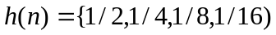
where h(0)=1/2, and h(n) is causal. Plot the following:
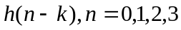
- Compute the output y(n) of the system in Question 1 for the following input sequence
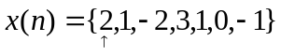. The arrow indicates x(0). What will be the length of y(n)? Show your working for full credit.
- Verify
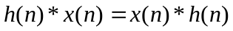(Commutativity of convolution) where *denotes the convolution operation.
- In MATLAB or C or any programming language of your choice, write a program to perform the convolution operation between any two sequences. The program should take in as inputs, the two input sequences and the output the convolved sequence. For full credit, you need to show/plot the two input sequences and the result. You can assume causality for the sequences but obviously, use finite sequences of reasonable length to show that your program works.

